**Business Insights Report**

**1. Overview of the Analysis**

This report presents key insights derived from the dataset, focusing on sales trends, customer preferences, and business performance. The analysis includes various visualizations to better understand the data and make informed business decisions.

**2. Key Findings and Visualizations**

**2.1 Missing Values Heatmap**

A heatmap was generated to identify missing values in the dataset. The visualization helps in understanding if any significant data points are missing and need to be addressed.

**Visualization:**

* A heatmap of missing values using Seaborn.
* 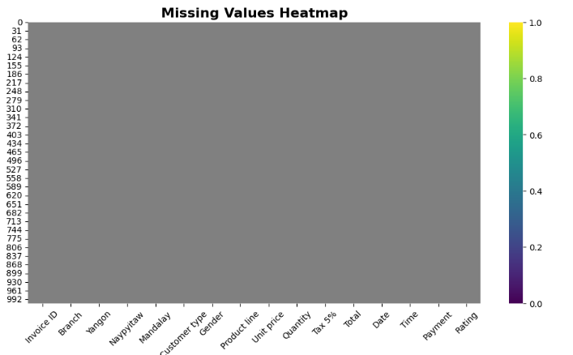Most columns have complete data, ensuring accurate analysis.

**2.2 Top Rated Product Lines**

A bar chart was created to show the product lines with the highest average ratings from customers.

**Insights:**

* Certain product lines consistently receive higher ratings, indicating strong customer preference.
* Businesses can focus on maintaining quality and availability of these products.

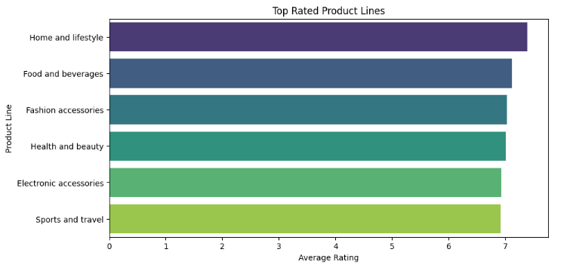

**2.3 Payment Mode Distribution**

A count plot was used to analyze the most commonly used payment methods among customers.

**Insights:**

* Identifies the preferred payment methods, which can help in optimizing checkout processes.
* Businesses can promote specific payment methods based on customer usage patterns.

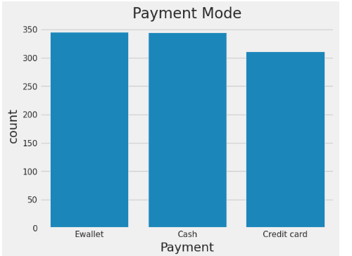

**2.4 Customer Gender Distribution**

A count plot was used to display the gender distribution of customers.

**Insights:**

* Understanding customer demographics can help tailor marketing strategies.
* If there is a significant imbalance, businesses can target campaigns to attract a more diverse audience.

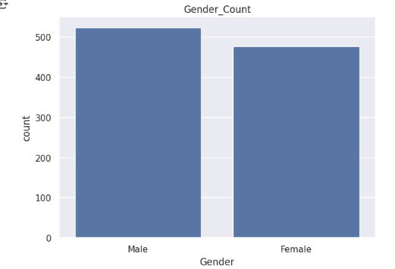

**3. Recommendations for Business Strategy**

Based on the analysis, the following recommendations are suggested:

* **Optimize product availability**: Ensure that top-rated products are always in stock.
* **Enhance digital payment options**: Promote the most popular payment methods for a smoother customer experience.
* **Targeted marketing campaigns**: Utilize customer demographic data to design effective marketing campaigns.
* **Data-driven decision-making**: Continue tracking sales trends to refine strategies over time.

**4. Conclusion**

This analysis provides actionable insights that can help businesses improve sales, optimize customer experience, and enhance decision-making based on data trends. Further analysis can be conducted to explore deeper relationships within the data.